**Deployment of React Application**

**Github Url:** <https://github.com/Deepika94/reactjs-demo>

**Flow of Execution**

1. Clone the Git repository <https://github.com/rvsp/reactjs-demo.git>
2. Create the docker file for the application & docker ignore & in the file mention the **node modules** to be ignore

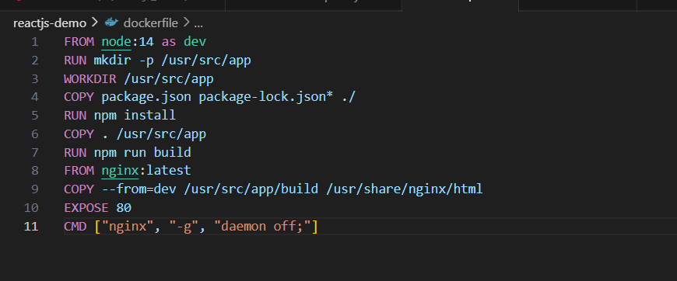

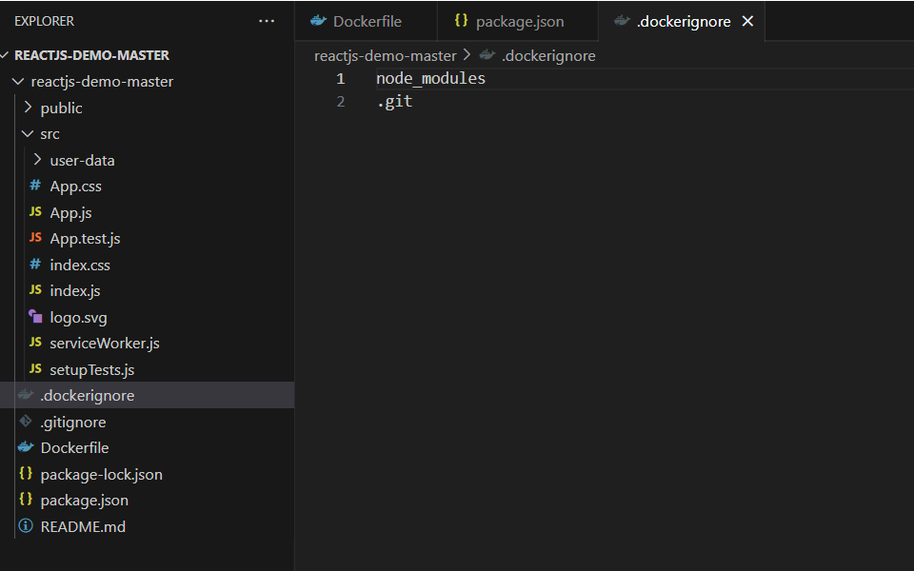

3.Create the docker-compose file using the above image

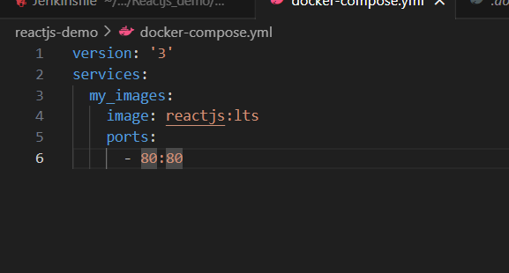

4.Creating the Build script to run the docker images

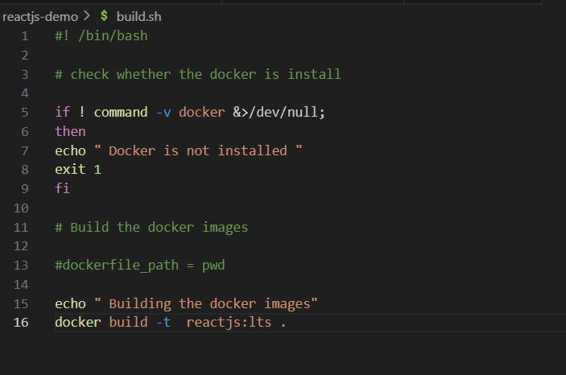

5. Install the Jenkins on the EC2 Instance with the commands

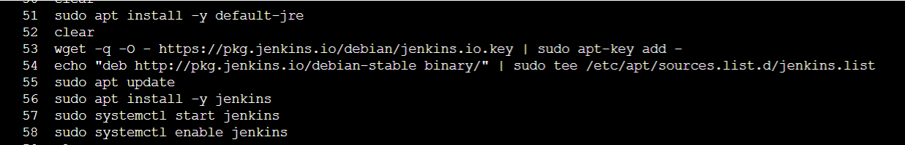

Access the Jenkins from the port 8080

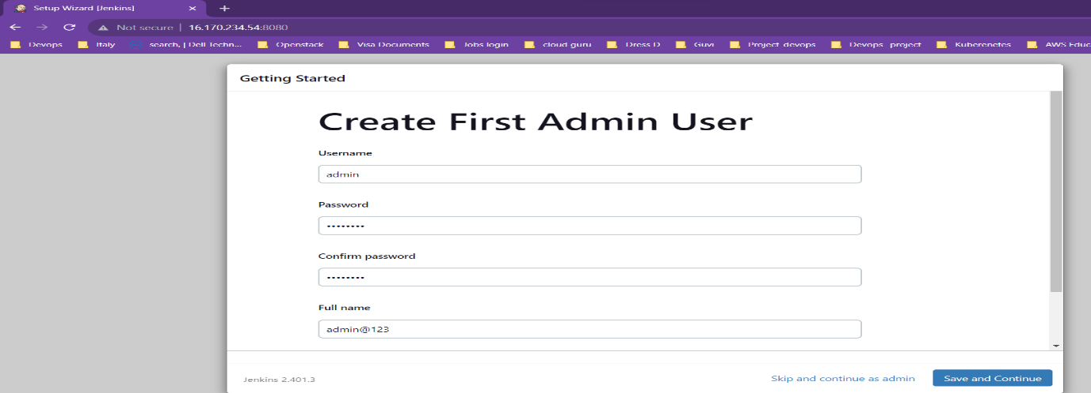

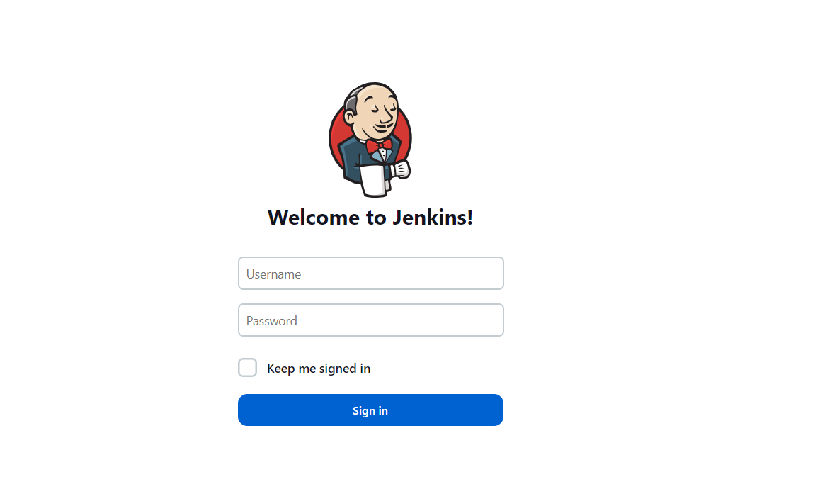

Install the Plugins **Docker & Docker pipeline** to execute the Docker Build in the Jenkins

In the Jenkins server Install the docker and add the ubuntu and Jenkins to execute the build

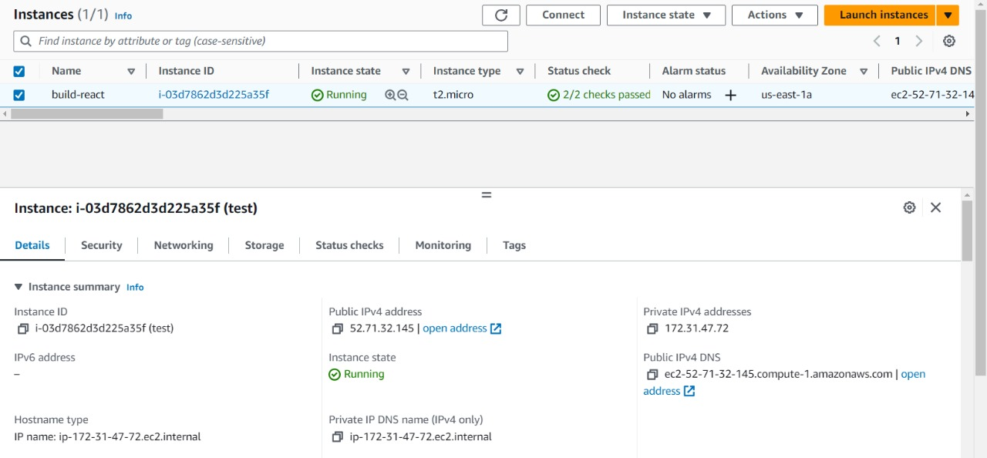

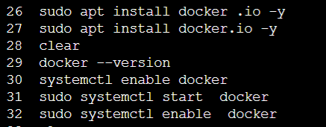

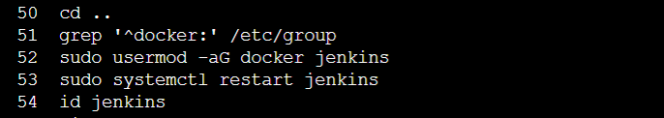

6. Push all the files to the Gilt repo

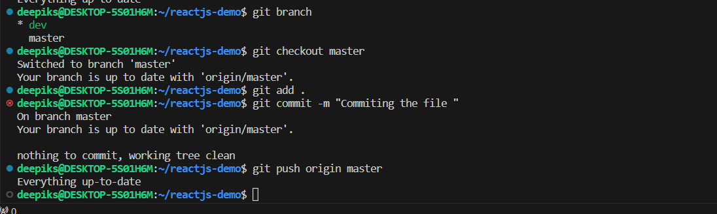

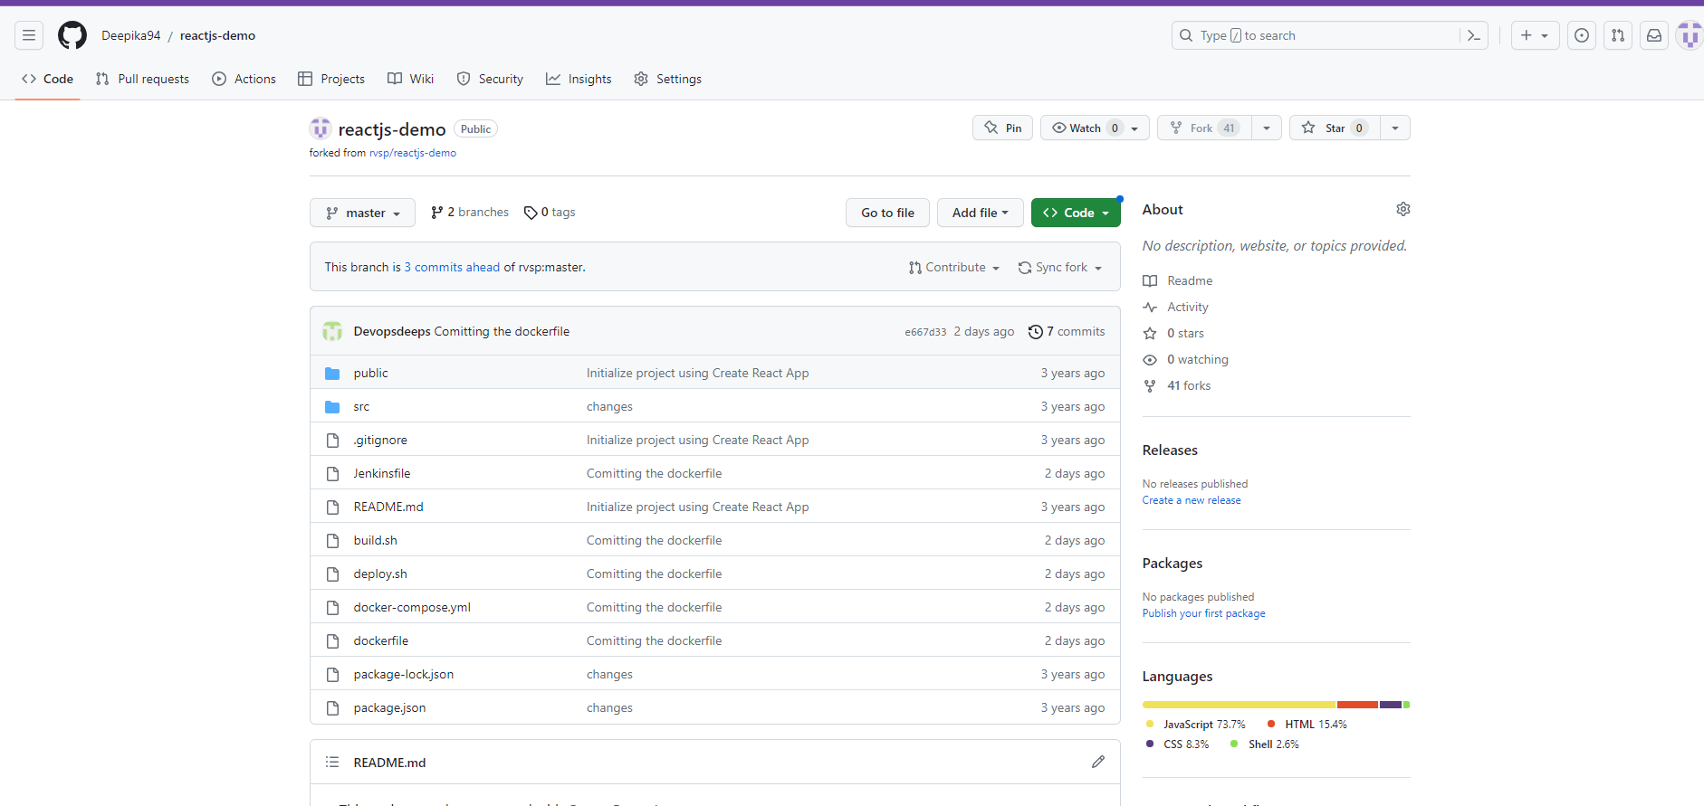

7. In the Jenkins create the Pipeline Job with the below

 In Jenkins having the below configure with Pipeline Jobs & Enable the Poll SCM

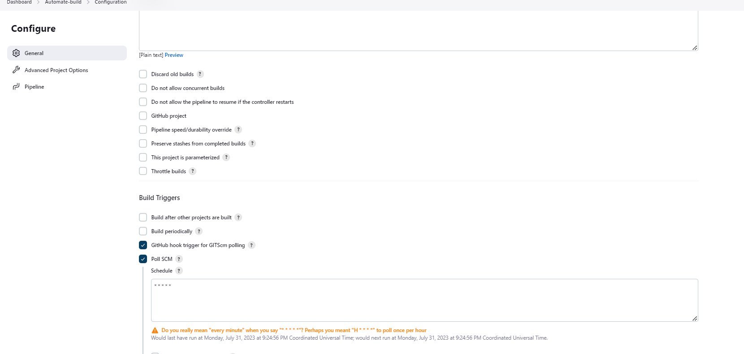

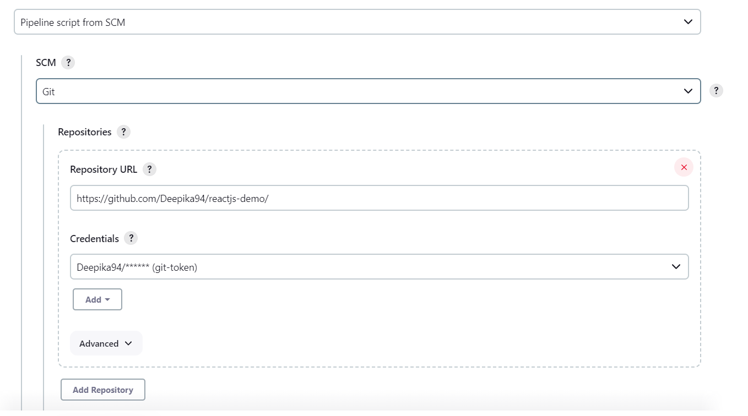

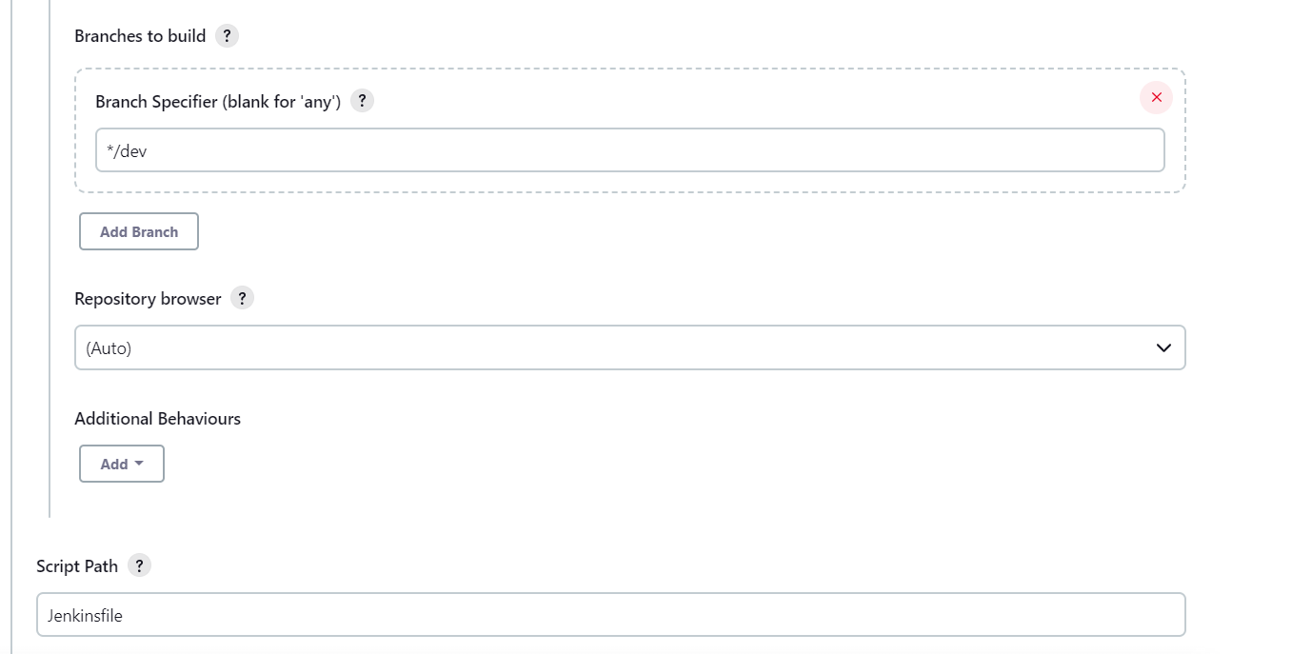

7. Create the Jenkins pipeline file

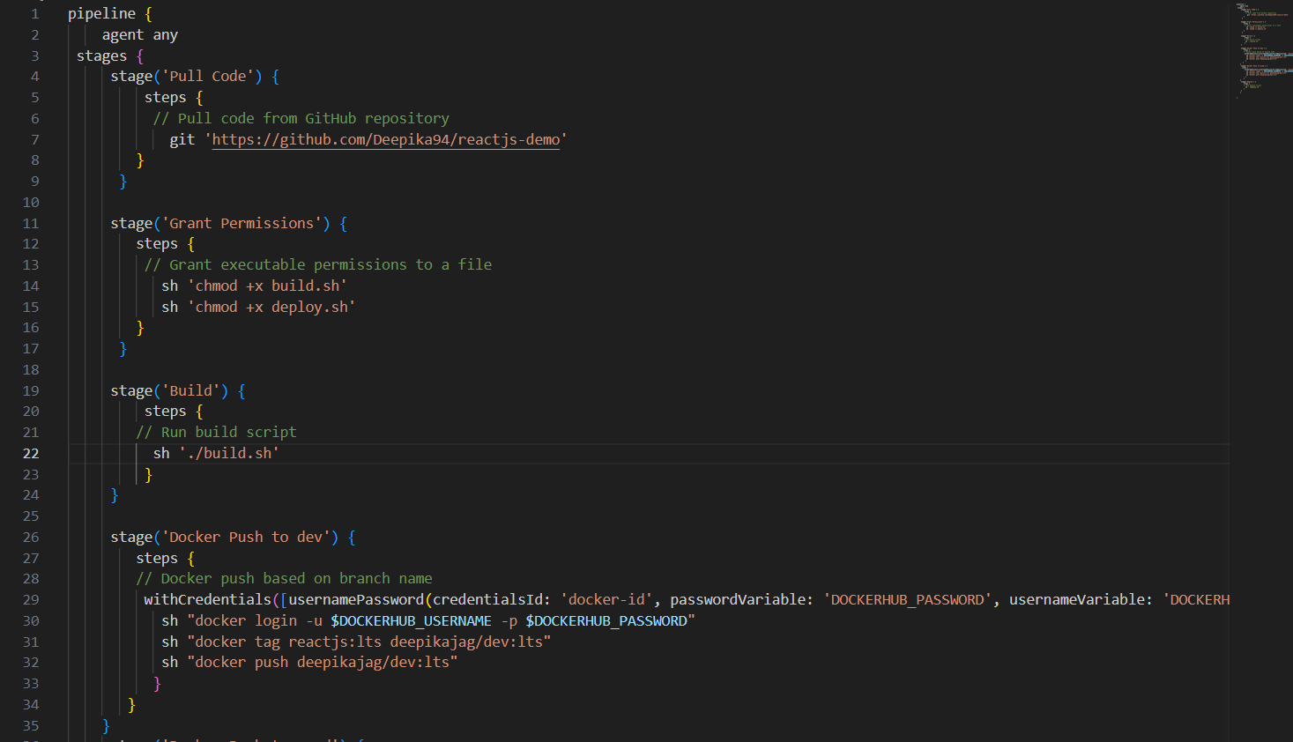

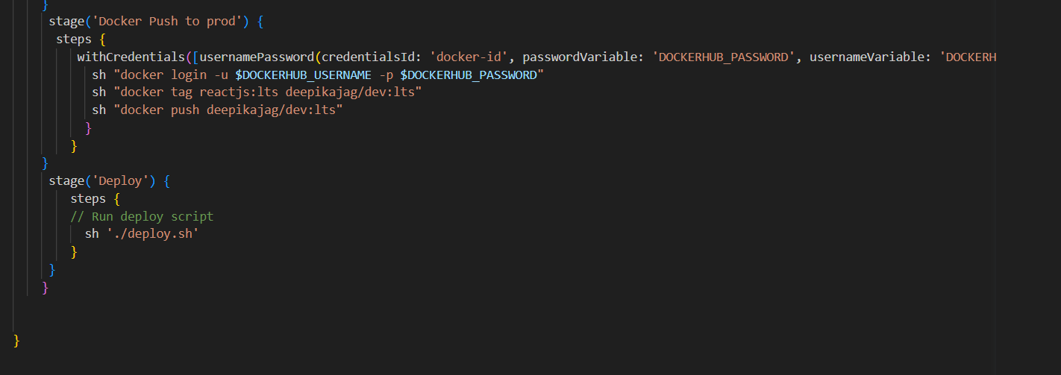

8.Create the deploy script to deploy the application in the EC2 instance

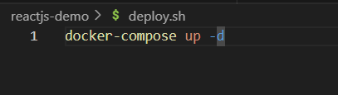

9. After building the Jenkins the image will be pushed to prod & dev in docker hub

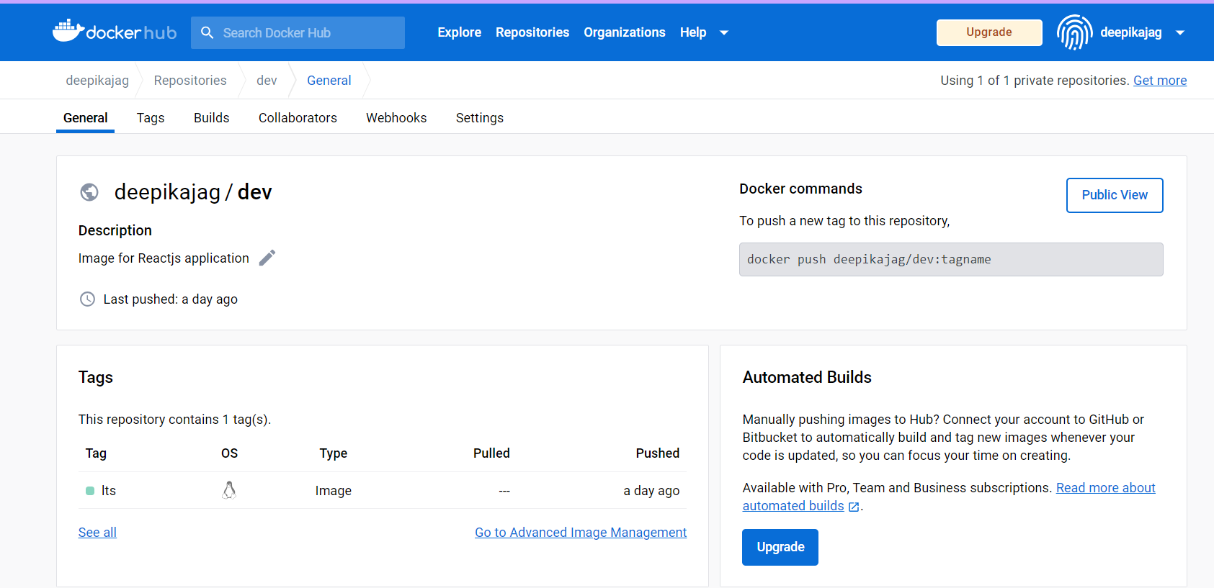

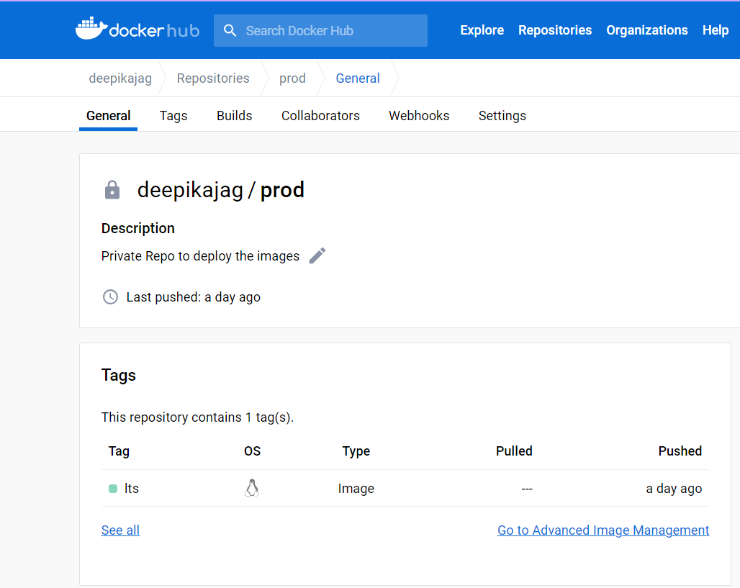

Security Group mention in the EC2 instance

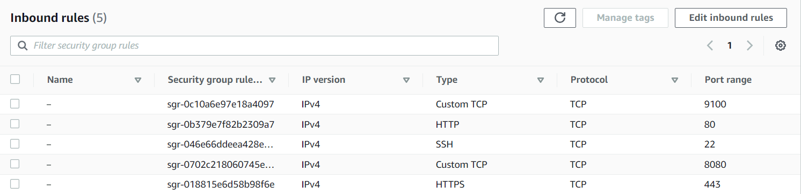

I can access the application from the browser

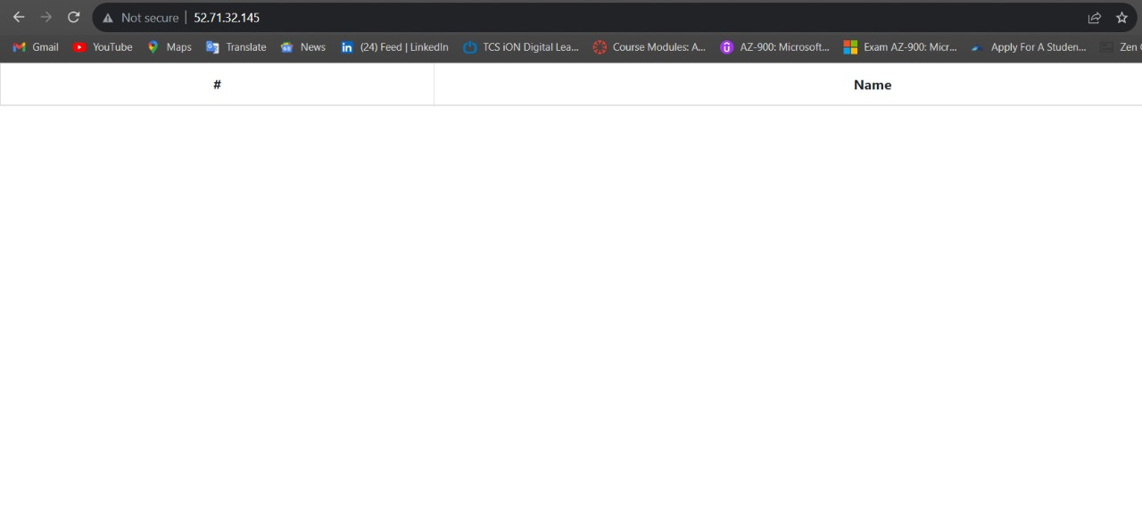

Adding the Uptime kuma to Monitor the application

